Retained Object

✅ What Is a Retained Object?
# Source: Chatbot (GPT-4-turbo) at [8/4/2025]
A Retained Object is a direct or indirect object that remains in a sentence after it has been changed from the active voice to the passive voice—even though passive sentences typically remove the subject.
It’s “retained” from the active form, which had two objects, and is kept even when the subject is removed.

🔸 Key Features:
# Source: Chatbot (GPT-4-turbo) at [8/4/2025]
- Found in passive voice constructions.
- Originates from ditransitive verbs (verbs that take two objects: direct + indirect).
- The indirect object or direct object remains after voice transformation.
- Common with verbs like: give, tell, send, show, offer, promise, teach, etc.

🔸 Examples of Retained Objects:
# Source: Chatbot (GPT-4-turbo) at [8/4/2025]
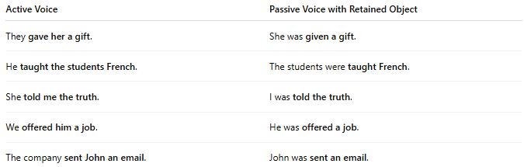
Active Voice | Passive Voice with Retained Object
They gave her a gift. | She was given a gift.
He taught the students French. | The students were taught French.
She told me the truth. | I was told the truth.
We offered him a job. | He was offered a job.
The company sent John an email. | John was sent an email.

🔸 How to Identify a Retained Object:
# Source: Chatbot (GPT-4-turbo) at [8/4/2025]
Ask:
- Was this originally an active sentence with two objects?
- Has one of those objects been kept in the passive?
✅ If yes, that remaining object is the retained object.

🔸 Compare:
# Source: Chatbot (GPT-4-turbo) at [8/4/2025]
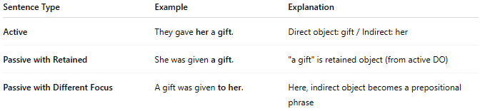
Sentence Type | Example | Explanation
Active | They gave her a gift. | Direct object: gift / Indirect: her
Passive with Retained | She was given a gift. | "a gift" is retained object (from active DO)
Passive with Different Focus | A gift was given to her. | Here, indirect object becomes a prepositional phrase

